**Docker Task**

**Task Description:**

Install docker on EC2 and explore the docker commands (docker images, containers, volumes, network)

**Techstacks needs to be used :**

* AWS EC2
* Docker

🡺 Installed docker on EC2: -  
  
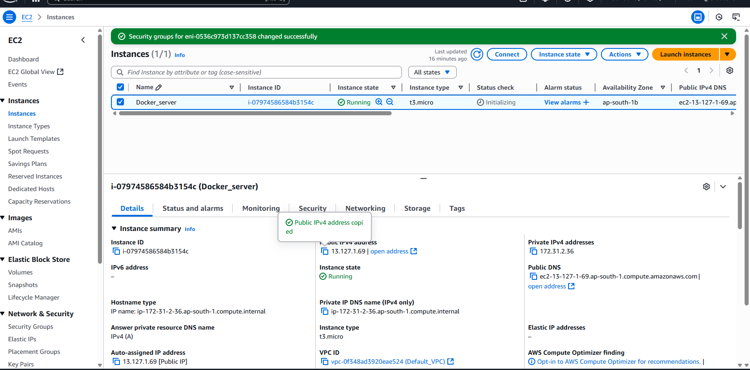

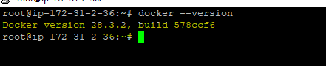  
  
🡺 Explored the docker commands (docker images, containers, volumes, network)

